Almely Ramos

User Monitor Documentation

Linux Admin

11/20/19

**Step 1: Run the script**

**command: ./user_monitor.sh**

**Step 2: Make sure that after you run the script these files are made.**



The “user.backup” file is a report of all the current users that are on the server.

Every time you run the script it will take a snapshot of the /etc/passwd and the users that reside in that folder.

**Step 3: Review the contents of the file**

Here is how it should look like-

**Checking Modifications in File with Script**

Run the script and make sure nothing was modified

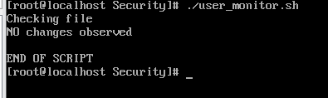

If nothing was changed then it will tell you.

If something was change it would tell you what has changed in between that blank space (Refer to picture above)

***Using Cron to automate script***

**Setting up script as a Cron Job**

For example, for this setup, I made sure the script ran every minute to make sure that the users in the passwd is backed up to this file.

Every 1 minute the script will run

(I will make sure to change this for the hour interval)

**Step 4: Make sure the cron job is running.**

This can be found in the /var/log under cron

Use Vi on the cron file and it will tell you every time the script has been ran.

That is how